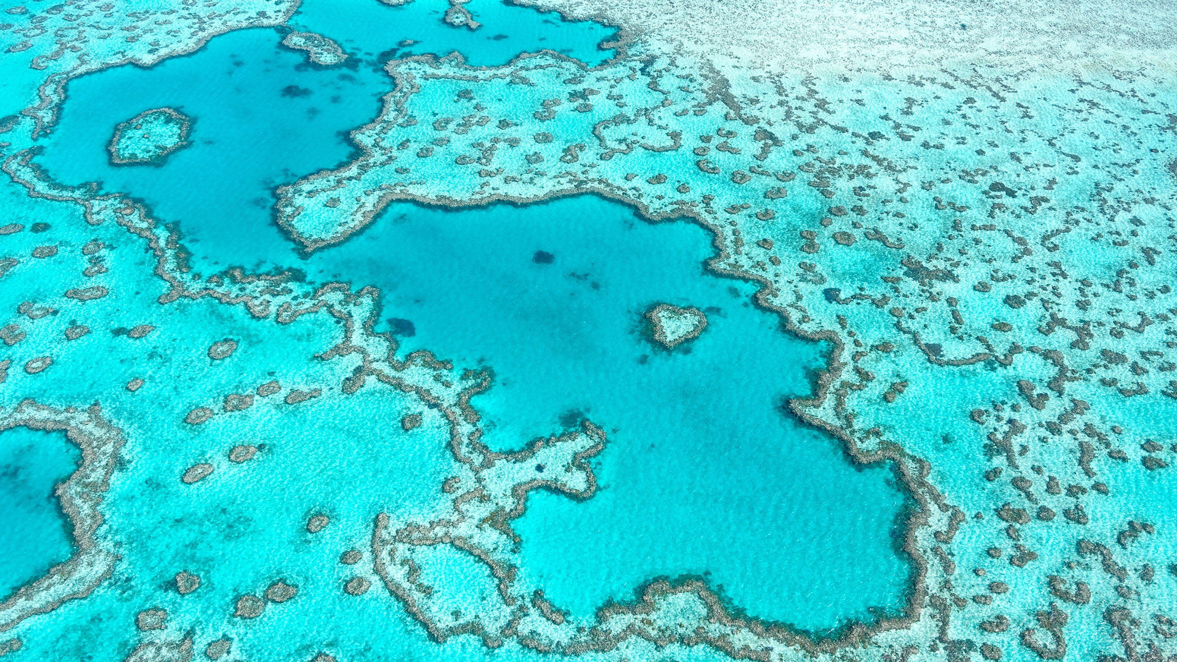

|  |  |
| --- | --- |
| Air Quality and Water Pollution per Country | |
|  |  |
| University of Wisconsin Eau ClaireNovember 1st, 2021Patrick Hearin Ph.D. |  |

|  |  |  |  |
| --- | --- | --- | --- |
|  |  | |  |
| Introduction | | | |
| Air Quality and Water Pollution Data Data was found on Kaggle that pertained to air quality and water pollution measurements around the world. The year the data was measured was 2020. This data gives accurate knowledge about the status of pollution on Earth.  This report will visualize the data, discuss the pros and cons of the visualizations, and find the countries that have the worst pollution. Three visualizations were made in Tableau. The first visualization shows the average air and water population on a map. Then a Bullet graph is used to find the worst water polluted countries and cities. Finally, a Treemap is used to find the countries with the worst average air and water pollution. | | Water pollution is an important issue since water is a fundamental part of life.  watering can | |
|  | |
|  |  | |  |
| Pollution Map | | | |
| Average Air and Water Pollution for Earth. | |  | |
|  | |

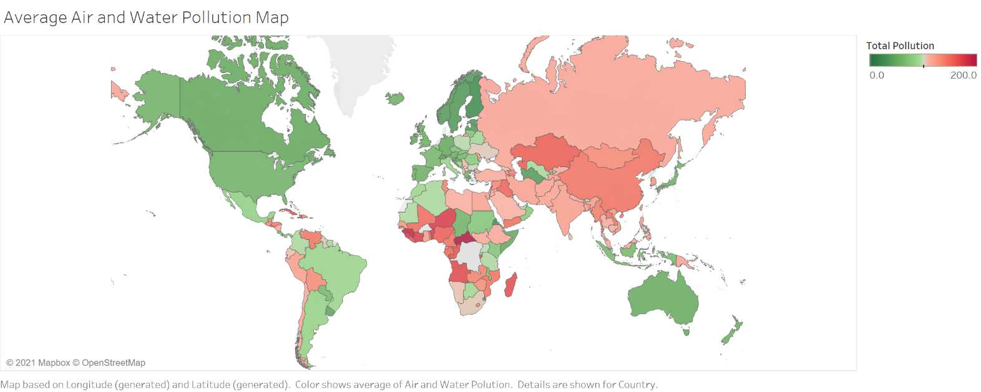

Figure 1 shows the general picture of air and water pollution. It shows the average of the air plus water pollution. The air pollution is calculated by subtracting the air quality from one hundred. Then both the air and water pollution are added together to make a range of pollution between zero and two hundred. The regions that have more measurements have a more accurate average. Some regions have few measurements, and the color would not be as accurate of an average comparatively. The map shows the most intense red colors in Africa. So, these countries are interesting in terms of finding the most polluted places on Earth.

Figure 1: Average air and water pollution using geographical data.

|  |  |  |  |  |  |  |  |
| --- | --- | --- | --- | --- | --- | --- | --- |
|  | | |  | |  | | |
| Polluted Water | | | | | | | |
| Countries Sorted by Highest Water Pollution. Figure 2: A Bullet graph sorted by countries that have the highest water pollution. The air quality is shown in black and blue. | | | | Figure 2 is sorted by countries that have the worst water pollution. Inspecting the Bullet graph shows that many African countries have high amounts of water pollution. Many of the African countries like Central African Republic also have black bullets: indicating that these countries also have low air quality. This visualization in the Tableau dashboard can be used to see which countries have accurate measurements. Or which countries just have one measurement and therefore an inaccurate average. | | | |
|  | | | |
|  | | |  | |  | | |
| Most Polluted Countries | | | | | | | |
| Countries Sorted by Worst Average Air and Water Pollution.   ge g  Figure 3 shows that there are many African countries that are in the highest air and water pollution area of the Treemap. This final visualization is the easiest to observe the location of the worst pollution. Although, it has no information about how many measurements were made in the given country. Another observation is air and water pollution are correlated with wealth and GDP.  Figure 3: Countries sorted by worst air and water pollution in a Bullet graph. | | | |  | | | |
|  | | | |
|  | | | | | | | |
|  |  | Conclusion   In conclusion many countries in Africa have the worst air and water pollution in the world. The visualizations produced give an assessment on the where the worst pollution in the world is located. Although, some of these countries have inaccurate averages since the whole country has one measurement. It would be interesting to sort the Bullet graph and Treemap to find the countries that have the least amount of air and water pollution. Overall, the air and water pollution around the world are on average distributed with respect to wealth. These conclusions make objective sense and can be easily comprehended from the visualizations. | | | |  |  |

**References:**

City-api.io (2020). World cities air quality and water pollutions. 2020. Retrieved from <https://www.kaggle.com/cityapiio/world-cities-air-quality-and-water-polution>